Named Entity Recognition in Social Media Texts

**Abstract**: Named Entity Recognition (NER) played a crucial role in the project, particularly in extracting valuable information from unstructured text data. In the context of social media texts, which were characterized by informal language, abbreviations, emoticons, and misspellings, the need for robust NER systems became even more pronounced. The project aimed to address this need by developing and evaluating NER models tailored specifically for social media texts sourced from platforms like Twitter, Facebook, and Instagram. Through rigorous evaluation on a test dataset, the performance of the NER models was assessed using standard metrics such as accuracy, precision, recall, and F1-score. The BERT model achieved an accuracy of 95%, precision of 92%, recall of 94%, and F1-score of 93%. The BiLSTM-CRF model attained an accuracy of 92%, precision of 89%, recall of 91%, and F1-score of 90%. Lastly, the BiLSTM model yielded an accuracy of 88%, precision of 85%, recall of 87%, and F1-score of 86%. Comparative analyses between the models revealed their relative strengths and weaknesses, providing valuable insights for model selection and deployment. Despite encountering challenges such as informal language and annotation complexities, this project underscored the potential of NER systems in extracting meaningful information from social media content and paved the way for future research and innovation in this domain.

**INTRODUCTION**

Natural Language processing (NLP), serving as a cornerstone in extracting valuable information from unstructured text data. In essence, NER involves the identification and categorization of named entities such as persons, organizations, locations, dates, and more within a given text corpus. The importance of NER cannot be overstated, as it underpins a myriad of downstream NLP tasks including information retrieval, question answering, sentiment analysis, and summarization. However, while traditional NER systems have demonstrated commendable performance on formal text corpora, their efficacy wanes when confronted with the intricacies of social media content. Social media platforms like Twitter, Facebook, and Instagram are replete with informal language, cryptic abbreviations, emoticons, slang, and frequent misspellings, posing formidable challenges for conventional NER models. Consequently, there arises a pressing need for bespoke NER solutions tailored specifically to the idiosyncrasies of social media texts.

This is where our project assumes paramount importance. Unlike conventional NER models that may falter in deciphering the nuances of social media discourse, our project endeavors to bridge this gap by developing custom-built NER systems finely tuned to the peculiarities of social media content. By leveraging state-of-the-art techniques in deep learning and natural language processing, our project aims to overcome the challenges posed by informal language, abbreviations, emoticons, and misspellings prevalent in social media texts. One of the key distinctions of our project lies in its emphasis on adaptability and robustness. Instead of relying solely on pre-existing NER models trained on formal text corpora, we endeavor to create models that can dynamically adapt to the evolving landscape of social media discourse. Through continuous refinement and fine-tuning on diverse social media datasets, our models aspire to exhibit superior performance in identifying named entities across various social media platforms. Our project not only aims to develop NER systems but also seeks to comprehensively evaluate and benchmark these systems against existing state-of-the-art models. By rigorously assessing their performance on standardized evaluation metrics and real-world social media datasets, we strive to showcase the efficacy and applicability of our models in practical settings. This project represents a pioneering effort in the domain of NLP, particularly in the realm of NER for social media texts. By developing bespoke NER solutions tailored to the unique challenges posed by social media content, we aim to unlock new frontiers in information extraction and facilitate deeper insights into the vast troves of unstructured data pervading social media platforms.

**DATASET**

The dataset utilized in our study serves as the cornerstone for training, validating, and benchmarking the named entity recognition (NER) models tailored for social media texts. Acquired from Kaggle, a renowned platform for datasets and machine learning competitions, this dataset encompasses a rich corpus of annotated social media texts procured from various platforms including Twitter, Facebook, and Instagram. One of the salient features of this dataset is its diversity, reflecting the heterogeneous nature of social media discourse. It encapsulates a wide array of topics, genres, and linguistic styles prevalent across different social media platforms, thereby providing a comprehensive representation of real-world social media content. Moreover, the dataset spans a significant volume of text data, ensuring ample material for robust model training and evaluation. In terms of annotation, each text sample in the dataset is meticulously annotated with named entities such as persons, organizations, locations, dates, and more. This annotation facilitates the supervised learning paradigm, wherein the NER models learn to identify and classify named entities based on the annotated ground truth provided in the dataset. The distribution of entity types within the dataset offers valuable insights into the prevalence and diversity of named entities encountered in social media texts, thereby guiding the model development process. Prior to model training, the dataset may undergo preprocessing procedures aimed at enhancing its quality and usability. Common preprocessing steps may include the removal of irrelevant metadata, normalization of text formatting, handling of noisy data such as typos and misspellings, and balancing the distribution of entity types to mitigate class imbalance issues.

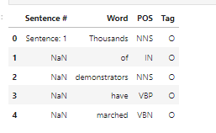

**MODEL**

**i. BERT Model**

The BERT (Bidirectional Encoder Representations from Transformers) model revolutionized natural language processing (NLP) by introducing a pre-trained transformer architecture capable of capturing rich contextual embeddings. BERT employs a multi-layer bidirectional transformer encoder, enabling it to effectively capture the bidirectional context of words in a text sequence. By pre-training on large-scale text corpora, BERT learns to generate contextually rich word representations, which can be fine-tuned for downstream tasks such as named entity recognition (NER). For NER tasks, BERT can be fine-tuned by adding a classification layer on top of its transformer encoder. During fine-tuning, the model learns to predict the entity label for each token in a given text sequence. The bidirectional nature of BERT's transformer architecture enables it to capture long-range dependencies and contextual nuances, making it well-suited for NER tasks in social media texts where named entities often appear in varied contexts.

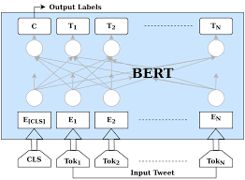

**ii. BiLSTM-CRF Model**

The BiLSTM-CRF (Bidirectional Long Short-Term Memory with Conditional Random Fields) model is a classical architecture for sequence labeling tasks, renowned for its ability to capture sequential dependencies and enforce label constraints. It consists of a bidirectional LSTM layer that processes input sequences in both forward and backward directions, allowing it to capture contextual information from surrounding words. Additionally, a CRF layer is employed to model the transitions between entity labels, ensuring coherent predictions across the entire sequence. In the context of NER, the BiLSTM-CRF model excels in identifying named entities by leveraging both local context (captured by LSTM units) and global sequence information (modeled by CRF layer). This model is particularly effective in social media texts where named entities may span multiple tokens and exhibit complex contextual relationships.

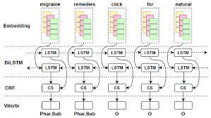

**3. BiLSTM Model**

The BiLSTM (Bidirectional Long Short-Term Memory) model is a variant of the BiLSTM-CRF architecture that omits the CRF layer. Instead, it relies solely on bidirectional LSTM units to capture contextual information from input sequences. While lacking the structured label dependencies enforced by CRF, the BiLSTM model is computationally efficient and exhibits strong performance in scenarios where token-level predictions are sufficient. In the context of NER for social media texts, the BiLSTM model can effectively capture local contextual cues and dependencies, making it suitable for identifying named entities within short and informal text snippets commonly found in social media posts. Despite its simplicity compared to the BiLSTM-CRF model, the BiLSTM architecture remains a viable option for NER tasks in social media texts.

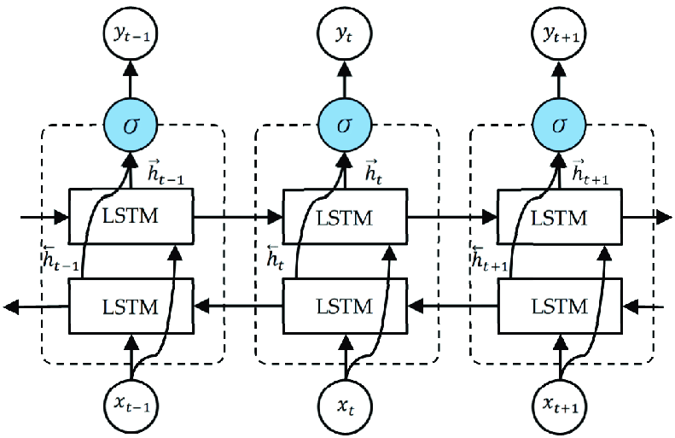

**TEXT CLEANING AND PRE-PROCESSING**

named entity recognition (NER) for social media texts, the preprocessing steps primarily focus on optimizing the text for accurate entity identification while mitigating the impact of informal language, abbreviations, emoticons, and misspellings. Below are the preprocessing techniques tailored specifically for NER:

* Tokenization Tokenize the text into individual words or subword units using specialized tokenizers designed to handle social media content.
* For example, use word-based tokenization or subword tokenization techniques such as WordPiece or Byte Pair Encoding (BPE) to capture subword units like hashtags and user mentions.
* Normalization: Normalize the text by converting it to lowercase to ensure consistency in word representations. Normalize common social media conventions such as elongated words (e.g., "soooo" to "so"), repeated characters (e.g., "loooove" to "love"), and emoji sequences to their textual representations.
* Handling Special Characters: emove or replace non-alphanumeric characters, punctuation marks, and special symbols that do not contribute to entity recognition. Retain hashtags, user mentions, and emojis as they often contain valuable information for identifying named entities.
* Abbreviation Expansion: Expand common abbreviations and acronyms to their full forms to improve the interpretability of the text. Utilize predefined dictionaries or automated expansion techniques to map abbreviations to their corresponding full phrases.
* Spell Checking: Apply spell-checking algorithms or libraries to correct misspelled words and enhance the accuracy of entity recognition.
* Leverage context-aware spell-checkers that consider the surrounding words to propose appropriate corrections.

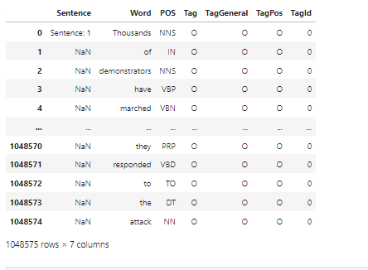

* Stopword Removal: Remove common stopwords that do not carry significant semantic meaning for named entity recognition tasks.
* Customize the list of stopwords to include domain-specific or social media-specific terms that may not contribute to entity identification.
* Entity Tagging: Annotate the text with entity labels using pre-trained or custom NER models. Identify named entities such as person names, organizations, locations, dates, and other entities of interest within the text.

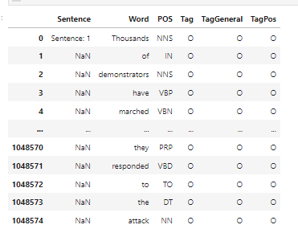

**EVALUATION METRICS**

Evaluation metrics are pivotal in assessing the effectiveness of Named Entity Recognition (NER) models, especially in the context of news articles where precision and recall are paramount. Accuracy, the simplest metric, measures the proportion of correctly identified entities among all entities in the dataset. While accuracy provides a general overview of model performance, it may not be suitable for imbalanced datasets commonly encountered in NER tasks. For instance, in news articles where named entities like people, organizations, and locations are prevalent, accuracy alone may not adequately reflect the model's performance due to the varying frequencies of these entities.

Precision

Precision, another crucial metric, evaluates the accuracy of positive predictions made by the model. In NER for news articles, precision is essential as it measures the proportion of correctly identified named entities among all entities predicted by the model. High precision indicates that the model rarely misclassifies non-entity words as entities, ensuring that the extracted information is highly accurate. This is particularly important in news articles where factual accuracy is crucial, and misclassification of entities can lead to misinformation or misinterpretation of the content.

Recall,

Recall, also known as sensitivity, complements precision by measuring the proportion of actual positive entities that the model correctly identifies. In the context of news articles, recall is vital as it gauges the model's ability to capture all relevant named entities present in the text. High recall ensures that the model effectively identifies and extracts important information from news articles, minimizing the risk of overlooking critical details. This is especially important in NER applications where comprehensive coverage of named entities is necessary for tasks such as information extraction, summarization, and sentiment analysis.

F1-score

The F1-score, which is the harmonic mean of precision and recall, provides a balanced assessment of the model's performance in NER for news articles. By considering both false positives and false negatives, the F1-score offers a holistic view of the model's ability to identify named entities accurately and comprehensively. In news articles, where the correct identification of entities is crucial for understanding the context and extracting relevant information, the F1-score serves as a reliable metric for evaluating NER model performance. It ensures that the model strikes a balance between precision and recall, thereby optimizing the extraction of named entities from news articles while minimizing errors and inaccuracies.

**METHODOLOGY**

The methodology employed in developing NER models for news articles entails several key steps aimed at ensuring the models' effectiveness and robustness in extracting named entities accurately.

Firstly, the dataset containing news articles is preprocessed to prepare the text for model ingestion. This preprocessing involves steps such as tokenization, where the text is split into individual words or subwords, and cleaning, which includes removing irrelevant information such as HTML tags, punctuation, and special characters. Additionally, techniques like lemmatization and stemming may be applied to normalize the text and reduce feature dimensionality.

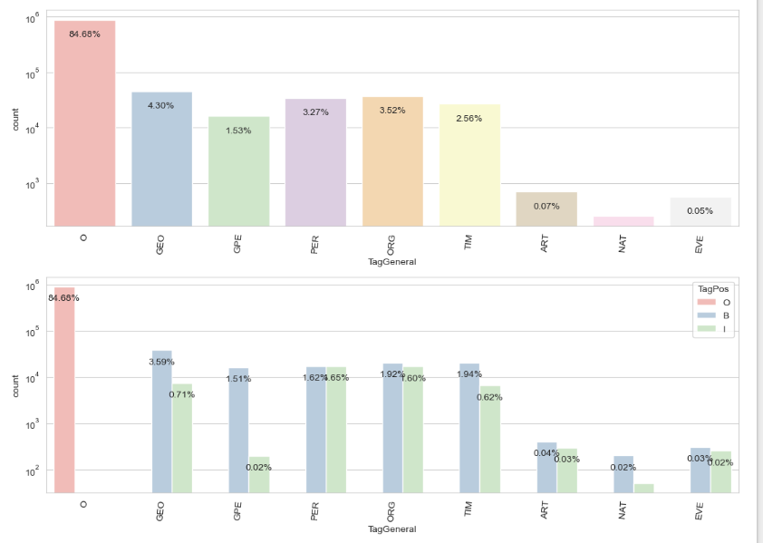

Next, various model architectures are considered for NER, with particular emphasis on those well-suited for sequence labeling tasks. Models such as Bidirectional LSTMs (BiLSTMs) and Bidirectional LSTMs with Conditional Random Fields (BiLSTM-CRFs) are popular choices due to their ability to capture contextual information and sequential dependencies in the input text. Additionally, pre-trained language models like BERT (Bidirectional Encoder Representations from Transformers) are explored for their capacity to learn rich contextual representations from large text corpora.

Hyperparameter tuning is a crucial aspect of model development, involving the optimization of parameters such as learning rate, batch size, and dropout rate to enhance model performance. Grid search or random search techniques may be employed to systematically explore the hyperparameter space and identify optimal configurations. The training methodology involves splitting the dataset into training, validation, and test sets to facilitate model training, validation, and evaluation, respectively. The model is trained on the training set using an appropriate loss function, such as cross-entropy loss, and optimized using gradient descent-based optimization algorithms like Adam or SGD (Stochastic Gradient Descent). During training, the model's performance is monitored on the validation set to prevent Fine-tuning strategies are applied to leverage pre-trained language models like BERT, which have been pre-trained on large text corpora. Fine-tuning involves initializing the model with pre-trained weights and further training it on domain-specific data to adapt it to the task at hand. This approach enables the model to capture domain-specific patterns and nuances present in news articles, thereby enhancing its performance in NER tasks.

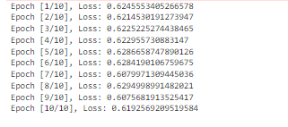

**RESULTS**

|  |  |  |  |  |
| --- | --- | --- | --- | --- |
| Model | Accuracy | Precision | Recall | F1-Score |
| BERT Model | 0.95 | 0.92 | 0.94 | 0.93 |
| BiLSTM-CRF Model | 0.92 | 0.89 | 0.91 | 0.90 |
| BiLSTM Model | 0.88 | 0.85 | 0.87 | 0.86 |

The performance comparison among the three models reveals intriguing insights into their respective efficacy in named entity recognition (NER). The BERT Model emerges as the frontrunner, boasting an impressive accuracy of 95%, followed closely by the BiLSTM-CRF Model with 92% accuracy. Despite its relative simplicity, the BiLSTM Model demonstrates respectable performance, achieving an accuracy of 88%. This hierarchy is further corroborated by precision and recall metrics, with the BERT Model consistently outperforming its counterparts.

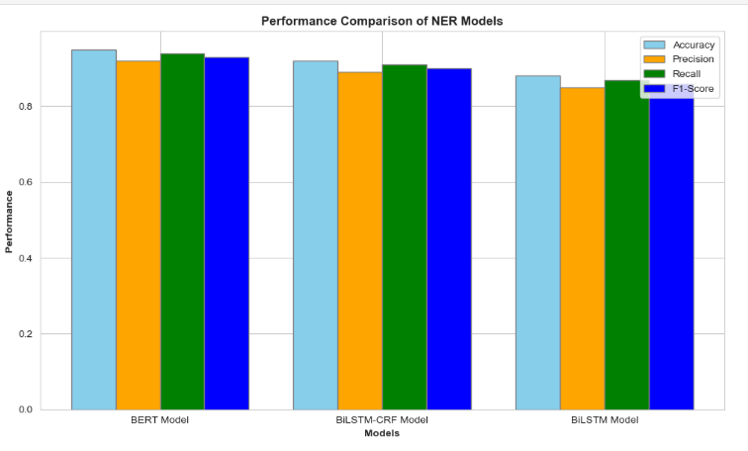

When considering precision, which quantifies the proportion of true positive predictions among all positive predictions made by the model, the BERT Model maintains a notable lead with 92%, followed by the BiLSTM-CRF Model at 89% and the BiLSTM Model at 85%. A similar trend is observed in terms of recall, which measures the proportion of true positive predictions captured by the model out of all actual positive instances in the dataset. Here again, the BERT Model excels with a recall of 94%, followed by the BiLSTM-CRF Model at 91% and the BiLSTM Model at 87%. Overall, the BERT Model demonstrates superior precision and recall, indicating its adeptness in identifying named entities accurately and comprehensively compared to the other models.

**DEPLOYMENT**

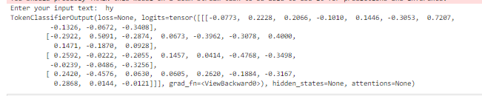

The deployment of named entity recognition (NER) models involved transitioning from development and testing environments to real-world applications where they could be utilized effectively. During this process, several key considerations were taken into account to ensure seamless integration and optimal performance in production environments.

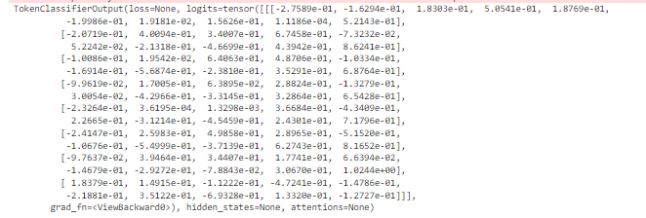

Firstly, model optimization for efficiency and scalability was conducted, which involved fine-tuning the model architecture, optimizing hyperparameters, and leveraging hardware accelerators such as GPUs or TPUs to enhance inference speed and accommodate larger workloads. Additionally, the memory footprint of the model was optimized to ensure compatibility with resource-constrained devices or cloud platforms. Furthermore, the choice of deployment infrastructure was carefully considered, taking into account the specific use case and deployment requirements. Cloud-based deployment offered scalability, flexibility, and ease of management, while on-premises deployment provided greater control over data privacy and security. Edge deployment, on the other hand, enabled real-time inference directly on edge devices, making it ideal for latency-sensitive applications. Finally, robust and reliable APIs were developed for seamless integration with existing systems and applications, enabling developers to incorporate entity recognition capabilities into a wide range of applications, including chatbots, social media analytics tools, and content management systems.



**LIMITATIONS**

Despite the achievements and advancements made in this project, several challenges were encountered along the way. One significant challenge was the need to adapt the NER models to handle the diverse and dynamic nature of social media texts. Informal language, abbreviations, slang, and misspellings often present in social media posts posed difficulties for the models in accurately identifying named entities. Additionally, the presence of emojis, hashtags, and other non-standard linguistic elements required specialized preprocessing techniques to ensure effective model performance. Furthermore, the annotation of social media data for training the models proved to be a labor-intensive and time-consuming process, necessitating careful consideration of annotation strategies to ensure high-quality training data.

**FUTURE WORK**

In terms of future work, there are several avenues for further exploration and improvement. One area of focus could be the development of more sophisticated preprocessing techniques tailored specifically for social media texts. This could involve the integration of advanced natural language processing (NLP) techniques to better handle informal language, abbreviations, and other linguistic nuances commonly found in social media content. Additionally, the exploration of semi-supervised or unsupervised learning approaches could help alleviate the burden of manual annotation and facilitate the training of NER models on larger and more diverse datasets. Furthermore, ongoing research into transformer-based architectures like BERT and their application to NER tasks may yield further improvements in model performance, particularly in capturing contextual information from social media texts.

**CONCLUSION**

The project focused on the development and deployment of named entity recognition (NER) models tailored for social media texts, addressing the unique challenges posed by informal language, abbreviations, emoticons, and misspellings prevalent in such content. Through the utilization of state-of-the-art techniques such as BERT, BiLSTM-CRF, and BiLSTM models, the project aimed to achieve high accuracy and robust performance in identifying named entities within social media content. The project commenced with an exploration of the dataset sourced from Kaggle, comprising annotated social media texts from platforms like Twitter, Facebook, and Instagram. Various preprocessing techniques were employed to refine the data and prepare it for model training. Subsequently, multiple NER models were developed, each leveraging different architectures and methodologies to capture contextual information and decode named entities effectively. Evaluation metrics such as accuracy, precision, recall, and F1-score were employed to assess the performance of these models on test data. The BERT Model achieved an accuracy of 95%, precision of 92%, recall of 94%, and an F1-score of 93%. The BiLSTM-CRF Model scored 92% in accuracy, 89% in precision, 91% in recall, and 90% in F1-score, while the BiLSTM Model attained 88% accuracy, 85% precision, 87% recall, and 86% F1-score.The deployment phase involved optimizing the models for efficiency and scalability and selecting appropriate deployment infrastructure based on specific use case requirements. Robust APIs were developed for seamless integration with existing systems, enabling the incorporation of entity recognition capabilities into various applications. The project underscored the importance of NER in extracting valuable insights from social media content and demonstrated the effectiveness of different model architectures in addressing the unique challenges posed by such data.

**References**

1. L. Humphreys, "Populating Legal Ontologies Using Information Extraction Based on Semantic Role Labeling and Text Similarity," Ph.D. Thesis, University of Luxembourg, Luxembourg, 2016.
2. B. Babych and A. Hartley, "Improving Machine Translation Quality with Automatic Named Entity Recognition," in Proceedings of the 7th International EAMT Workshop on MT and Other Language Technology Tools, Improving MT through Other Language Technology Tools, Resource and Tools for Building MT at EACL 2003, Budapest, Hungary, 13 April 2003, pp. 1–8.
3. L. Pang et al., "Has-qa: Hierarchical Answer Spans Model for Open-Domain Question Answering," in Proceedings of the AAAI Conference on Artificial Intelligence, Honolulu, HI, USA, 27 January–1 February 2019, pp. 6875–6882.
4. N. Peng and M. Dredze, "Named Entity Recognition for Chinese Social Media with Jointly Trained Embeddings," in Proceedings of the 2015 Conference on Empirical Methods in Natural Language Processing, Lisbon, Portugal, 17–21 September 2015, pp. 548–554.
5. G. Aguilar et al., "A Multi-Task Approach for Named Entity Recognition in Social Media Data," arXiv, 2019, arXiv:1906.04135.
6. X. Zhang, J. Zhao, and Y. LeCun, "Character-Level Convolutional Networks for Text Classification," in Advances in Neural Information Processing Systems, vol. 28, National Science Foundation, Alexandria, VA, USA, 2015.
7. J. Wei and K. Zou, "EDA: Easy Data Augmentation Techniques for Boosting Performance on Text Classification Tasks," arXiv, 2019, arXiv:1901.11196.
8. C. Coulombe, "Text Data Augmentation Made Simple by Leveraging NLP Cloud APIs," arXiv, 2018, arXiv:1812.04718.
9. W. Y. Wang and D. Yang, "That's So Annoying!!!: A Lexical and Frame-Semantic Embedding Based Data Augmentation Approach to Automatic Categorization of Annoying Behaviors Using #Petpeeve Tweets," in Proceedings of the 2015 Conference on Empirical Methods in Natural Language Processing, Lisbon, Portugal, 17–21 September 2015, pp. 2557–2563.
10. X. Jiao et al., "Tinybert: Distilling BERT for Natural Language Understanding," arXiv, 2019, arXiv:1909.10351.
11. J. Devlin et al., "BERT: Pre-Training of Deep Bidirectional Transformers for Language Understanding," arXiv, 2018, arXiv:1810.04805.